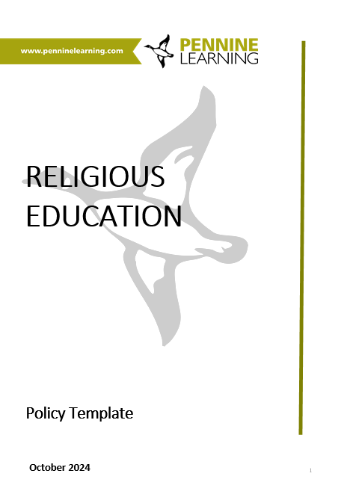

Religious Education: Policy Template

Introduction

A school’s policy for RE should be clear and concise, explaining the intent for the subject within the school. The definition and aims of RE should be highlighted and there should be an indication about what is taught and why and how you are implementing the intent.

The RE policy document should follow the same format as other policy documents in your school, but the unique situation of RE outside the National Curriculum means that certain points need clearly stating. The text below represents a template that can be used as a basis for your own policy. Sections in red italics are editorial comments or suggestions of what you need to add and supplement.

Remember that RE is directly the responsibility of the head and the governors, not only the RE coordinator.

PLEASE NOTE THIS POLICY TEMPLATE HAS BEEN DEVISED TO MATCH MAINTAINED OR ACADEMY SCHOOLS USING THE WEST YORKSHIRE SYLLABUS, ‘BELIEVING AND BELONGING’.

………………………………………………………………………………………………………………………………………………

Policy for Religious Education

Responsibility
Date
Review date

Purpose of RE

Our vision for RE is based on the national guidance issued by the RE Council in 2024 and the local agreed syllabus, 2024.

The text below is from the Believing and Belonging Agreed Syllabus 24. Adapt or rewrite as needed for your school. Church schools may wish to include further reference to ethos.

‘Schools should, through their RE programmes, aim systematically to prepare students for the spiritual and intellectual challenges of living in a world with diverse religions and beliefs as well as non-belief”
Big Ideas for Religious Education, Wintersgill 2017

This syllabus is called Believing and Belonging because it weaves two key threads:

First, it is about beliefs and values. It aims to develop learners’ understanding of religions/worldviews, exploring their commonality and diversity.

Specifically, RE:

a. Enables learners to develop a broad and balanced understanding of religions/worldviews.

RE’s primary purpose is to give learners a broad understanding of Christianity, other religious traditions and non-religious beliefs, and understand how these are woven into human experience and applied to life and decisions.

b. Empowers learners to develop and use critical thinking skills.

Well taught, RE is a rigorous academic subject, supporting problem solving and critical thinking skills. It will inspire and motivate learners to enquire into religious and purposeful questions. Engaging and stimulating RE helps to nurture informed and resilient responses to misunderstanding, stereotyping and division. It offers a place in the curriculum where difficult or ‘risky’ questions can be tackled within a safe but challenging context.

Secondly, the syllabus is about ‘belonging’. It aims to nurture pupils’ awareness of the treasury of diverse beliefs and cultures, as well as sensitivity to the questions and challenges that these can present. Ultimately, we all share a common humanity and our own patch of the Earth. In this way RE plays a part in helping pupils to discover their own place, identity and journey through life.

The RE curriculum

The RE curriculum is based on the Local Agreed Syllabus for Local Authority Name produced by SACRE for teaching from September 2024 (or alternative if applicable). The syllabus is freely available on local authority websites).

The aims of RE in our school are based around six threads or ‘pathways’ through which the most important features of RE may be understood. Coherent and sequential learning is built on these pathways and then earthed by thematic and systematic study of specific religions/worldviews.

Our RE in school therefore aims to:
• develop progressive understanding of the ‘pathways’ and
• build rich and profound knowledge of religions/worldviews.

Church schools may wish to add a paragraph about focus on Christianity or other ways the syllabus is applied.

The knowledge entitlement for pupils has been based on the detailed subject content tables in the syllabus and schemes of work (outline these here if you wish or just refer to the syllabus).

To support delivery of informed and interesting RE, teaching is based on a sequence of units of work. Representing a progression of learning in the areas of study. (Edit as appropriate how you have used the core and focus units)

Achievement and Progress

We assess progress of pupils against the end of key stage statements in the syllabus. The units of work specify age-related expectations within the key stages.

Outline your practice in more detail.

Schools are required to report on progress in RE in line with the core principles of assessment outlined by the DfE. We will report to parents on individual pupils’ achievement relative to the end of key stage statements in at least years 2 and 6 or when a pupil leaves school. (This paragraph represents the minimum statutory requirement – edit as needed)

RE lessons

RE is timetabled so that pupils are provided with ….. hours of RE each year. Lessons will be delivered…. (outline your pattern briefly but explicitly – ie weekly lessons, drop-down days, cross curricular, or combination)

Lessons are normally taught by the class teacher/ a qualified teacher covering PPA/an HLTA. The school has a subject leader who supports and monitors the subject.

We encourage and promote teaching and learning through …. (outline any preferred learning styles or pedagogical approach)

The place of RE in our school

RE has a key part in our curriculum. It also makes an important contribution to pupils’ wider development, wellbeing and understanding.

In this section outline links and contributions to aspects of the broad curriculum and experience of pupils.

As part of enriching pupils’ experiences, we…. (include here ongoing projects, such as arranging visits to places of worship – don’t be too detailed as the policy needs to last for a few years…)

RE makes a substantial contribution to pupils’ SMSC development and Fundamental British Values by, for example, …….

The subject links to PSHE education by …….

RE supports our commitment to equality through…..

We value the support given to RE through links with the local and wider community, such as….

Withdrawal from RE

Parents have a statutory right to withdraw a child from religious education. This right of withdrawal exists for all pupils in all types of school, including schools with and without a religious designation. If a parent is considering withdrawal from RE, we will listen to their concerns, inviting them to do so with the head teacher or other representative of the school. We work hard to ensure that any reservations or doubts may be accommodated to avoid withdrawal but recognise that a parent has this right if reservations cannot be resolved. Any formal decision to withdraw should be made in writing to the head teacher. We will ask parents if they wish to continue the withdrawal each year.

If a pupil is withdrawn, the school has a duty of care to look after the pupil, but not to provide alternative education. Any arrangements made must not incur extra cost for the school or the local authority.

This paragraph represents statutory requirements – add as appropriate but remember there is a statutory right of withdrawal. Note that the child should be supervised in school – not sent or allowed home.

Further details on withdrawal from RE can be found in the document Managing Withdrawal from RE produced by SACRE and available at https://www.penninelearning.com/media/buviy21k/21_3_withdrawalplusguidanceplus20_04-1.pdf

Useful guidance has been produced by NAHT and NATRE on withdrawal from RE and can be found here https://www.naht.org.uk/advice-and-support/curriculum-and-assessment/dealing-with-requests-to-withdraw-from-religious-education/

Enquiries and questions

The school welcomes enquiries or questions about RE. In the first instance parents should contact their child’s class teacher.


www.penninelearning.com

© Pennine Learning Associates Ltd 2026

This document is licensed under Creative Commons CC-BY-NC-SA. In summary this means you can use it freely but not for commercial gain. You must attribute it to Pennine Learning Associates and, if you make any alterations, you must still attribute the original material to us. You can read the full licence here: https://creativecommons.org/licenses/by-nc-sa/4.0/.

